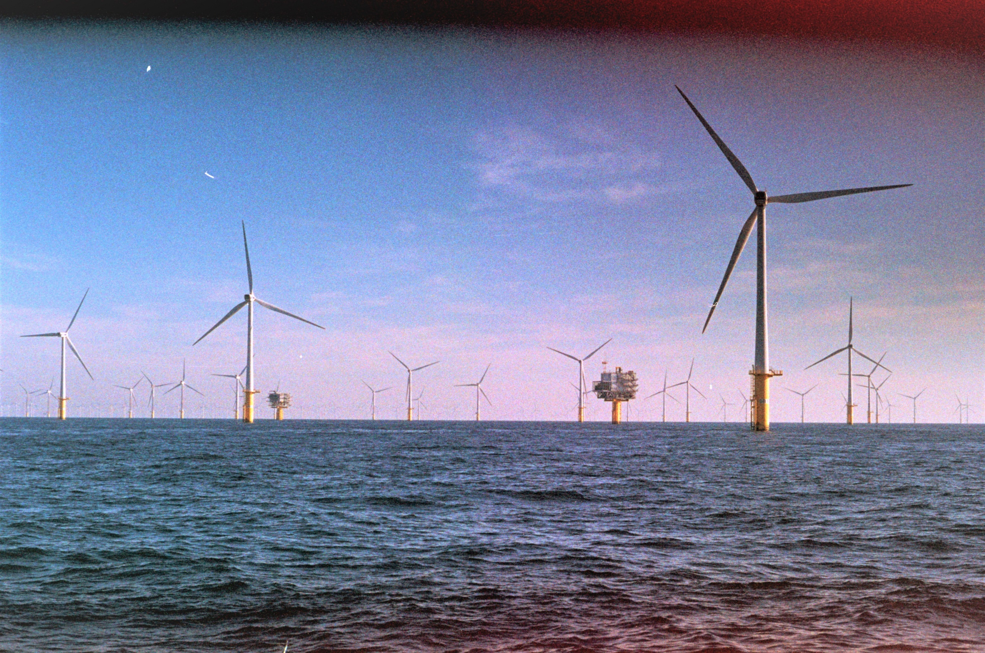**J.A.C. de Bruijn**

**Pelagic fish abundance and harbour porpoise presence in operational offshore wind farms**

**MSc Biology Internship**

**Final Submission**

**27 February 2025**

**Joost de Bruijn**

**1307312**

**Wageningen University & Research**

**Supervisor: Jeroen Hubert**

**Marine Animal Ecology**

**Institute Biology Leiden**

**Supervisor: Hans Slabbekoorn**





Table of Contents

Abstract 3

Keywords 3

Introduction 4

Materials & Methods 7

Study site 7

Multi-sensor frames 8

Experimental design & deployments 9

Data processing and statistics 9

Model for pelagic fish abundance 9

Model for harbour porpoise presence 9

Results 10

Location Type 10

Diurnal patterns 10

Seasonal patterns 10

Pelagic fish – harbour porpoise interaction 10

Discussion 15

Pelagic fish inside OWFs 15

Harbour porpoise inside OWFs 15

Diurnal and seasonal patterns 16

Pelagic fish – harbour porpoise interaction 17

Conclusion 17

References 18

Appendix 24

Appendix A 24

Appendix B 24

Appendix C 25

# Abstract

The number of offshore wind farms (OWFs) in the North Sea is rapidly increasing, as they are essential for the transition to sustainable energy. OWFs introduce various environmental changes, such as hard substrate, electromagnetic fields, hydrological changes, and noise pollution. However, little is known about the impact of OWFs on pelagic fish and harbour porpoises, as these species are not directly associated with the turbines. This study investigated the impact of OWFs on pelagic fish abundance and harbour porpoise presence using paired deployments of multi-sensor frames in OWFs and at control sites near shipwrecks. The results revealed that OWFs harboured fewer pelagic fish while maintaining a higher harbour porpoise presence than the control sites. Strong temporal patterns emerged, with increased nocturnal activity and seasonal variations, and significantly more fish when porpoises were present. Overall, our findings revealed that this OWF zone in the Southern Nord Sea, consisting of multiple OWFs, deterred pelagic fishes while attracting harbour porpoises. Thanks to the paired experimental design, we could isolate and reveal the impact of OWFs, contributing to a broader understanding of their long-term effects on pelagic fish and harbour porpoise behaviour, and providing valuable insights into their suitability as habitats.

# Keywords

Offshore wind farms, pelagic fish, echosounder, harbour porpoise, passive acoustic monitoring, southern North Sea

# Introduction

Offshore wind farms (OWFs) are increasingly important in the transition towards sustainable energy, as they offer a scalable alternative to current fossil fuel-based energy sources (Farkat Diógenes et al. 2020; Sadorsky 2021). By 2019, Europe’s total OWF capacity had already reached 22 GW, as part of ambitious plans to achieve climate neutrality by 2050 with an increase to 450 GW of offshore wind energy (The European Green Deal 2019; WindEurope 2019). The construction of OWFs introduces various environmental changes, including significant acoustic impacts, with seismic surveys during the preparation phase and pile driving during construction generating substantial noise pollution (Dannheim et al., 2020; Mooney et al., 2020). However, relatively few studies have investigated the impact of the operational phase (Inger et al. 2009). Meanwhile, operational OWFs have an estimated lifespan of 30 years and must cover considerable marine habitat before becoming cost-effective, potentially making this the most impactful phase (Scheidat et al. 2011; Mooney et al., 2020).

The impacts human activities have in the North Sea are becoming increasingly clear with the growing presence of marine structures like oil and gas platforms and shipwrecks (Van de Pol et al. 2023). As a result, the predominantly soft-sediment associated species composition in the North Sea is changing in areas where hard substrates are introduced (Lefaible et al. 2023). These hard substrates create habitats for species like filter feeders, which can further influence the ecosystem by filtering the water column, reducing turbidity, enhancing light penetration, and increasing organic matter availability (Slavik et al. 2019; Degraer et al. 2020; Jammar et al. 2025). Furthermore, underwater power cables are introduced into the North Sea, emitting electromagnetic fields (EMFs)(CMACS 2003). Animals such as benthic elasmobranchs, which rely on EMFs for orientation, navigation, and prey detection, are sensitive to these emissions and are likely disturbed by them (Hermans et al. 2024). Human activities are also contributing to a changing soundscape, with seismic surveys and ship engines raising noise pollution levels (Madsen et al. 2006; Mooney et al., 2020). Noise pollution causes behavioural changes in many marine species as they depend on sound for foraging, navigation, and communication (Madsen et al. 2006; Cox et al. 2018; Slabbekoorn et al. 2018; Mooney et al., 2020; Kok et al. 2018; 2021). Collectively, these environmental changes could have a substantial impact on the North Sea ecosystem.

In operational OWFs, these human-introduced environmental changes converge, making these areas hotspots of change (Watson et al. 2024). The subsurface structures in OWFs (windmill foundations and scour protection) act as artificial reefs altering species composition, food availability and increase the overall biodiversity (Petersen and Malm 2006; Raoux et al. 2017; Degraer et al. 2020). These effects are similar to those of artificial reefs and shipwrecks, stretching the need to better distinguish the specific impacts of OWFs (Lemasson et al. 2024). Fishing and shipping restrictions inside operational OWFs make them potentially act as marine protected areas, offering refuge for various species (Ashley et al., 2014; Wisniewska et al., 2018; Püts et al., 2023). However, windmill turbines produce a continuous source of underwater noise (Betke et al., 2005; Marmo et al., 2024), which could potentially mask communication or disrupt pelagic fish behaviour (Madsen et al. 2006; Cox et al. 2018; Slabbekoorn et al. 2018; Mooney et al. 2020; Kok et al. 2021). Current studies are mostly based on short-term observational series and focussed on the reef-associated biofouling communities on the turbine pillars (Dannheim et al. 2020; Zupan et al. 2023; 2024). Therefore, to understand the effects of operational OWFs on overall biodiversity, it is crucial to monitor species that are not directly associated to the turbines, but do play a key role in the North Sea ecosystem. (Degraer et al. 2020).

Pelagic fish are essential in nutrient-rich ecosystems like the North Sea, by serving as the mid-trophic-level between primary consumers and higher trophic levels, thereby supporting larger predators (Brockmann et al., 1990; Cury et al. 2000; Stephenson and Smedbol 2001; Palomera et al. 2007). Pelagic species commonly found in the North Sea include Atlantic herring (*Clupea harengus*), European sprat (*Sprattus sprattus*), European anchovy (*Engraulis encrasicolus*), Atlantic mackerel (*Scomber* *scombrus*), Atlantic horse mackerel (*Trachurus trachurus*), and Garfish (*Belone belone*) (Daan et al., 1990). Previous studies on pelagic fish inside OWFs show an extremely diverse species composition (Lindeboom et al. 2011; Krägefsky 2014), attraction to underwater structures (Klima and Wickham 1971; Soldal et al. 2002), and no spatial deterrence from sound (Kok et al. 2021; Hubert et al. 2024). However, studies on fish in OWFs more often focus on residential demersal fish species, as they can be more easily tracked with acoustic tags, whereas pelagic fish migrate out of the area quickly, making it hard to study them with tags (Iafrate et al. 2016; Van Der Knaap et al. 2021). It is still largely unknown what effects operational OWFs have on pelagic fish, while they are crucial in the tropic cascade, making them valuable indicators of ecosystem stability (Cury et al. 2000).

The harbour porpoise (*Phocoena phocoena*), a top predator in the North Sea whose distribution range overlaps with many OWFs, is an important species in the ecosystem (Wilson and Mittermeier 2014; Xu et al. 2020; Gilles et al. 2023). Construction of OWFs significantly deters harbour porpoises, reducing their presence within a 20 km radius (Tougaard et al. 2009; Vallejo et al. 2017; Brandt et al. 2018). Previous studies are less conclusive about the effects of operational OWFs, reporting contradictory findings such as spatial avoidance (Teilmann and Carstensen 2012), while others find no effect (Diederichs et al. 2008; van Polanen Petel et al. 2012; Vallejo et al. 2017; Collier et al. 2022), and some studies report attraction of harbour porpoise (Scheidat et al. 2011; Raoux et al. 2017; Fernandez-Betelu et al. 2022). These differences suggest that species distribution is influenced by diurnal, seasonal and geographical patterns, which further complicates our understanding of harbour porpoise interactions with operational OWFs (Diederichs et al., 2008; Schaffeld et al. 2016; Clausen et al. 2021; Fernandez-Betelu et al. 2022). Potential benefits of OWFs include a higher abundance of prey species, while disadvantages can be linked to noise disturbances from turbines, maintenance, and research activities (Scheidat et al. 2011; Wisniewska et al. 2018). In any case, as a top predator, the harbour porpoise plays a crucial role in ecosystem functioning and food-web structure of the North Sea, making it a valuable indicator species (Williams et al. 2004; Peltier et al. 2013; Lambert 2021).

There is a clear predator-prey relationship between harbour porpoises and pelagic fish, as the diet of harbour porpoises includes pelagic species such as Atlantic herring, and European sprat (Wisniewska et al. 2016; Lambert 2021). Mainly smaller pelagic fish species are eaten by harbour porpoises, and their diet also includes benthic fish and invertebrates (Cury et al. 2000; Lambert 2021). Predator-prey interactions also occur between pelagic fish, as smaller pelagic fish serve as prey for larger predatory fish, making certain species simultaneously predators as prey (van Denderen et al. 2018). Species presence and abundance are highly context-dependent and vary with habitat, and environmental changes, which even further complicates the food-web structure of the North Sea (Frelat et al. 2022). Understanding these predator-prey dynamics is therefore essential to assess the impact of operational OWFs on habitat suitability for pelagic fish and harbour porpoises in the North Sea (Sveegaard et al. 2012).

In the current study, we simultaneously examined pelagic fish abundance and harbour porpoise presence in operational OWFs. We deployed paired bottom-moored multi-sensor frames inside OWFs and outside them, close to shipwrecks. We aimed to answer the following research questions: (1) Do operational OWFs affect the abundance of pelagic fish and the presence of harbour porpoises? (2) Do temporal factors (diurnal and seasonal) influence pelagic fish abundance and harbour porpoise presence? (3) Is there a relationship between pelagic fish abundance and harbour porpoise presence? Pelagic fish abundance is expected to be influenced more by primary producer dynamics in the North Sea than by OWFs, while harbour porpoises may be attracted to OWFs due to increased biomass in these areas. Furthermore, both pelagic fish and harbour porpoises are likely influenced by temporal patterns as some pelagic fish seasonally migrate, and both taxonomic groups exhibit distinct diurnal behaviours. Finally, based on their predator-prey relationship, an interaction between pelagic fish abundance and harbour porpoise presence is expected. However, as pelagic fish are only a portion of the harbour porpoise diet, the strength of this interaction remains uncertain.

# Materials & Methods

## Study site

Multi-sensor frames were placed in different OWFs and close to shipwrecks located along both sides of the Belgian-Dutch border (Figure 1). All OWFs are located inside a large zone of multiple offshore wind farms close together, and the shipwrecks are located southwest and northeast of this OWF area, at similar distances from the coast. The OWFs are located between 24 km to 40 km of the Belgian-Dutch coast (Appendix A). Meta information on the number of turbines, the max power in megawatts, construction date, distance to the coast and surface area are available (EMODnet 2024), and based on this turbine density, power yield per turbine and power yield per km2 were calculated (Appendix A). The shipwrecks included are located between 19 km to 52 km of the Belgian-Dutch coast and meta information on the wrecks is available (Appendix B). All deployments were made in 2021 or 2023, with the first deployments made on July 12, 2021, and the last on October 4, 2023 (Table 1) (Appendix C).

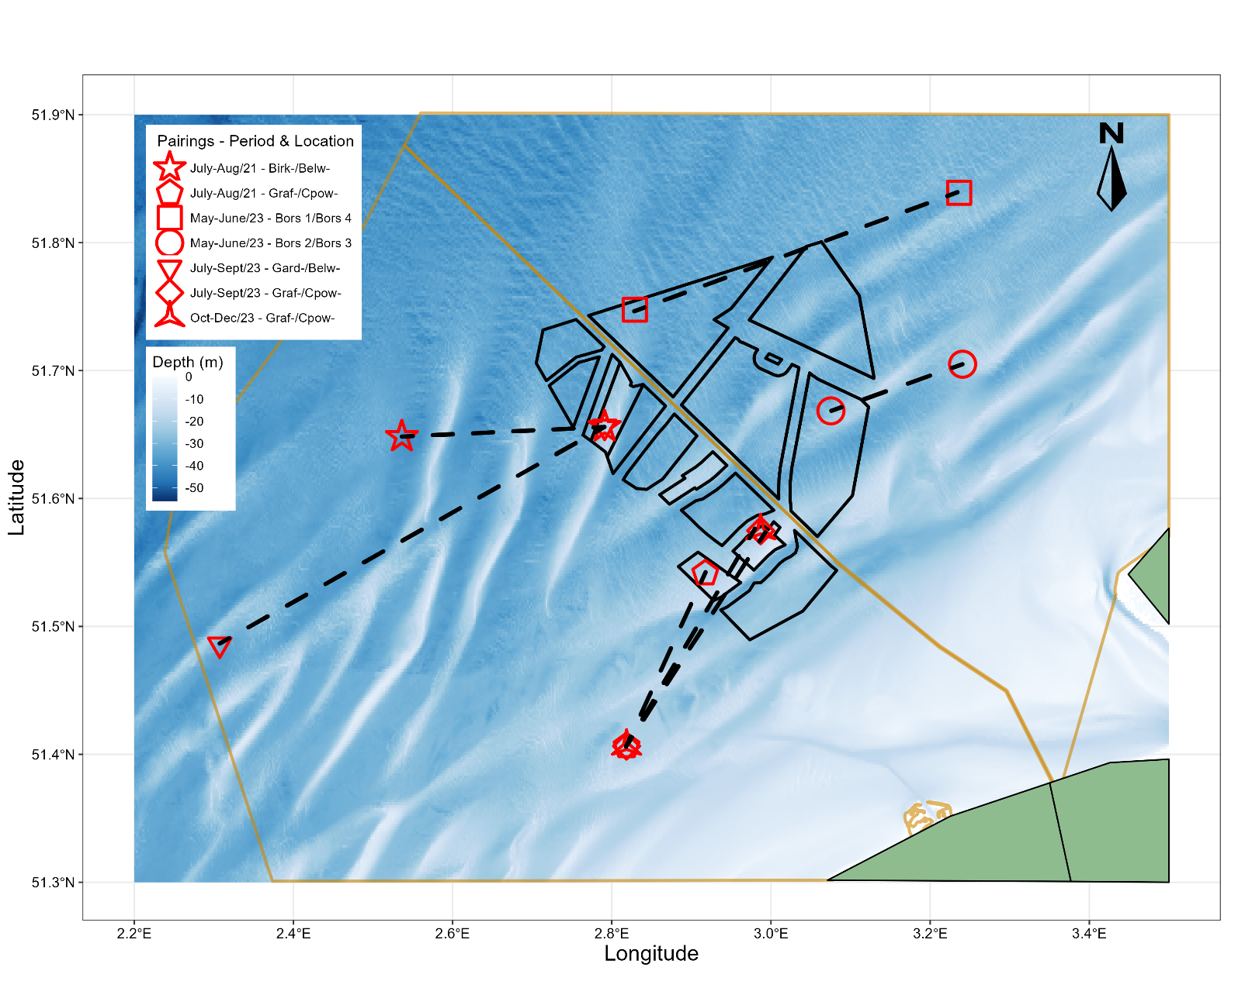

Figure 1: The map of the study area displays multiple offshore wind farms as polygons outlined in black, with coastal water borders marked in yellow. Multi-sensor frame deployments are represented by red shapes, where each shape corresponds to a specific deployment pair, and dashed lines connect paired deployments. The locations range between 24 km and 40 km from the Belgian-Dutch coast, highlighted in green. The background illustrates the bathymetry of the area, transitioning from shallow waters in white to progressively deeper areas in darker blue.

Table 1: Meta information of 14 deployments made during the study on deployment location type (Control or OWF), meters distance to nearest hard substrate (shipwreck or turbine), echosounder frequency, POD type, deployment period of the frames and year of deployment.

|  |  |  |  |  |  |  |  |
| --- | --- | --- | --- | --- | --- | --- | --- |
| Name Station | Meta information on deployments | | | | | | |
|  | Location type | Pairing | Dist. nearest structure (m) | WBAT freq (kHz) | POD type | Deployment period | Year |
| Birkenfels | Control | 1 | 156 | 70 & 200 | C-POD | 12/07-30/08 | 2021 |
| Belwind | OWF | 1 | 336 | 70 & 200 | C-POD | 12/07-30/08 | 2021 |
| Grafton | Control | 2 | 61 | 70 & 200 | C-POD | 12/07-30/08 | 2021 |
| Cpower (A) | OWF | 2 | 428 | Lost | C-POD | 12/07-30/08 | 2021 |
| Gardencity | Control | 1 | 95 | 70 & 200 | C-POD | 05/07-03/09 | 2023 |
| Belwind | OWF | 1 | 336 | 70 & 200 | C-POD | 05/07-03/09 | 2023 |
| Grafton | Control | 2 | 61 | 70 & 200 | C-POD | 05/07-03/09 | 2023 |
| Cpower (B) | OWF | 2 | 452 | 70 | C-POD | 05/07-03/09 | 2023 |
| Shipw. Bors. I | Control | 1 | 98 | 70 & 200 | C-POD | 07/05-16/06 | 2023 |
| Bors. IV | OWF | 1 | 682 | 70 & 200 | C-POD | 07/05-16/06 | 2023 |
| Shipw. Bors. II | Control | 2 | 40 | 70 & 200 | C-POD | 07/05-16/06 | 2023 |
| Bors. III | OWF | 2 | 555 | 70 | C-POD | 07/05-16/06 | 2023 |
| Grafton | Control | 1 | 61 | 70 & 200 | F-POD | 04/10-04/12 | 2023 |
| Cpower (B) | OWF | 1 | 450 | 70 & 200 | C-POD | 04/10-04/12 | 2023 |

## Multi-sensor frames

We used four bottom-moored multi-sensor frames (1.6 x 1.2 x 1 m; L x W x H) all equipped with an echosounder, C-POD, hydrophone, and acoustic release system. Echosounders are acoustic systems that emit high-frequency sounds which reflect on individuals and schools of fish and are frequently used in fisheries research to monitor the abundance of free-ranging fish (Sonny et al. 2006; Simmonds and Maclennan 2008; Hawkins et al., 2014; Kok et al. 2021). The echosounders [wide band autonomous transceiver (WBAT), Kongsberg Maritime AS, Bergen, Norway] were equipped with both an upward pointing wideband split-beam 70 kHz (ES7018CD, Simrad, Horten, Norway) and a split-beam broadband 160-250 kHz (ES200-7CDK-split, Simrad) transducer. The echosounders were calibrated using standard spheres (ICES, 2015). The C-POD or continuous porpoise detector is a stationary passive acoustic monitoring device that can detect echolocation signals from porpoises allowing for abundance and behavioural estimations (Clausen et al. 2011; Chelonia Ltd 2012; Berges et al. 2019). The C-PODs and one F-POD (Chelonia Inc., Cornwall, UK) record echolocation click activity. The recorded signals are immediately processed on the C-POD allowing it only to log time and duration of sounds matching the acoustic criteria of harbour porpoises (Scheidat et al. 2011). The hydrophones used were all SoundTrap models (Ocean Instruments, Auckland, New Zealand), either a ST300, a ST600 HF (high frequencies), or a ST4300 HF recorder with four external HTI-96-MIN hydrophones (High Tech Inc., Long Beach, MS). Lastly, the acoustic release system (VR2AR, VEMCO, Billings, MT) was used to recover the frame after the experimental period.

## Experimental design & deployments

During the study a combined total of 14 deployments were made inside five OWFs and close to five shipwrecks sites (Table 1). Deployments were made in a pairwise setup with 7 pairs, simultaneously deploying inside an OWF and close to a shipwreck site, allowing to reduce the temporal and spatial variations. For pelagic fish abundance, only six out of the seven pairs were included as one echosounder was lost, while for the harbour porpoise detections a F-POD (newer version of the C-POD) was used at one of the deployments (Table 1). The deployment periods ranged between 7 to 10 consecutive weeks, with distances to the nearest structure, either a turbine or shipwreck, ranging from 40 to 740 meters (Table 1). Echosounders were programmed to be active for 10 minutes each hour, with the first 5 minutes at 70 kHz followed by 5 minutes at 200 kHz. The C-PODs were recording continuously, but data during the 10-minute echosounder activity was excluded, leaving 50 minutes of usable recordings per hour. The hydrophones had a sampling rate of 40000 Hz and duration ranged between 10 to 60 minutes per hour depending on battery life.

## Data processing and statistics

The raw echosounder data was processed using automatic functions of LSSS (Large Scale Survey System; version 2.14, MAREC, Bergen, Norway), detecting fish marks, and the surface line, after which the latter was manually checked. The area backscattering coefficient (sa), a proxy for biomass, was integrated for each 0.5 m of the water column every 30 seconds (Maclennan et al. 2002), after which the log10 mean sa over 5 minutes per hour (log10(sa)/h-1) was calculated. This process was performed for both frequencies, but only a -50 dB background level at the 70 kHz frequency was used for further data analysis. The data processing of the raw C-POD data was automatically performed by the C-PODs, as recorded signals were immediately processed. The C-POD data was expressed in harbour porpoise detection positive minutes (DPM) which were used to calculate the detection positive hours (DPH). The DPH was defined as the proportion of hours in which porpoises were detected relative to the total station sample time (Fernandez-Betelu et al., 2022). The sunlight positions, which normalized differences in daylight length were calculated using the package *suncalc* v0.5.1 (Thieurmel and Elmarhraoui 2022). We analysed differences in pelagic fish abundance and harbour porpoise presence using generalized additive models (GAMs) to determine the effects of location type, temporal patterns and interaction between taxonomic groups. We used a GAM with a Gaussian distribution and identity link-function for the pelagic fish biomass. For the harbour porpoise presence/absence data a GAM with binominal distribution and logit link-function was used. All data was processed using R Statistical Software v4.4.1 (R Core Team 2023), and GAMs were performed using the package *mgcv* v1.9-1 (Wood 2011).

### Model for pelagic fish abundance

$$\log_{10}\left(Area Backscattering Coefficient\right) \sim Location Type + DPH$$

$$+ Sun Position + Week Number + Pairing Set$$

### Model for harbour porpoise presence

$$DPH \sim Location Type + \log_{10}\left(Area Backscattering Coefficient\right)$$

$$+ Sun Position + Week Number + Pairing Set$$

# Results

## Location Type

We monitored pelagic fish abundance and harbour porpoise presence at 14 locations using a pairwise setup with multi-sensor frames. We found that the area backscattering coefficient ($s_{a}$), a proxy for pelagic fish biomass, was significantly lower in OWFs as observed in five out of six pairs (intercept: 2.197, OWF: -0.149, *p* < 0.001; Figure 2a). In contrast, harbour porpoise presence was significantly higher in OWFs (intercept: -0.350, OWF: 0.237, *p* < 0.001; Figure 2b), a pattern observed in six of the seven sample pairs. Due to the pairwise setup of this study, pairing set was included as a random effect to account for variation between measured pairs, indicating a strong non-linear effect, with different pairs likely contributing significantly to the variance in pelagic fish abundance and harbour porpoise presence (F = 167.79, edf = 5.399, p < 0.001).

## Diurnal patterns

On a diurnal timescale, the area backscattering coefficient shows a non-linear effect by sun position, which is a proxy for the time of day, highlighting daily variations in biomass (F = 86.03, *edf* = 9.117, *p* < 0.001; Figure 4a). The area backscattering coefficient is significantly higher at night for both location types, with the OWFs again consistently showing a lower mean biomass. The harbour porpoise presence also shows a significant non-linear effect by sun position (χ2 = 13.83, *edf* = 3.582, *p* = 0.0117; Figure 4b). The station coverage for each week is shown directly below.

## Seasonal patterns

On a seasonal timescale, the area backscattering coefficient exhibits a non-linear effect by week number, indicating seasonal variation throughout the year (F = 19.15, *edf* = 9.051, *p* < 0.001; Figure 3a). Biomass shows a decline in spring (weeks 19–24) and increases again in summer (weeks 27–35) for both OWFs and controls, with the OWFs consistently having a lower mean biomass during these periods (Figure 3a). In autumn (weeks 40–48), biomass reaches its highest mean values, displaying a stable trend at both location types (Figure 3a). The harbour porpoise presence also follows a non-linear effect by week number, indicating seasonal influence (χ2 = 448.32, *edf* = 8.717, *p* < 0.001; Figure 3b). Presence decreases in spring (weeks 19-24) after rising again in summer (weeks 27-35) at both location types, with consistently higher presence in the OWFs except in week 35. In autumn (week 40-48), presence detections peak, and become higher at the control site. The station coverage for each week is shown directly below.

## Pelagic fish – harbour porpoise interaction

When the harbour porpoise presence is included in the pelagic fish abundance model, an interaction between the two taxonomic groups is found, indicating that pelagic fish abundance is significantly higher when harbour porpoises are present (intercept: 2.197, OWF: 0.060, *p* < 0.001; Figure 5). This pattern is observed in 10 out of 13 deployments with echosounder measurements.

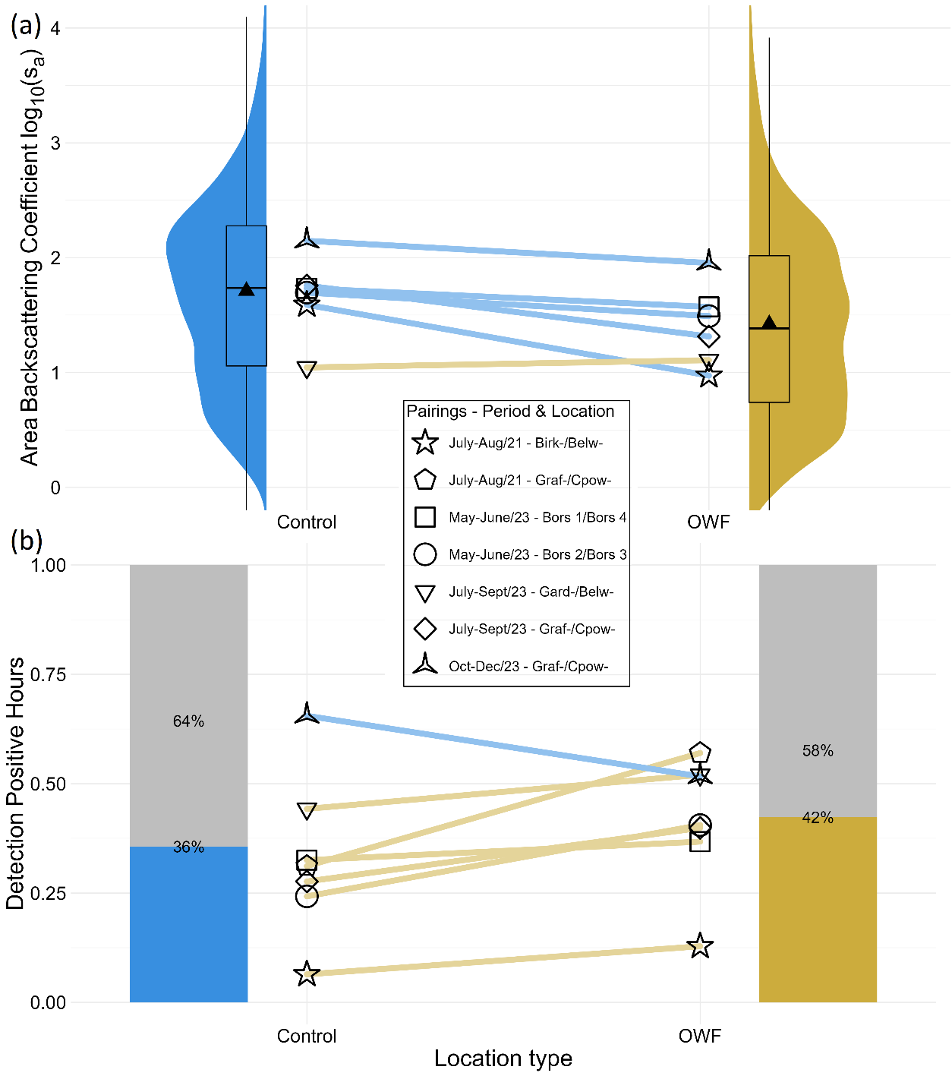

Figure 2: Overview of all individual pairing sets against the two location types with control (blue), and OWF (yellow). Coloured lines connect the paired deployment sets, with the shape representing a specific deployment pair and the line colour indicating the location type with the highest abundance or presence. (a) For five out of six pairing sets the fish area backscattering coefficient is higher outside OWFs. The complete data distribution shows the same result with the mean area backscattering coefficient being smaller inside OWFs. (b) For six out of seven pairing sets the porpoise detection positive hours are higher inside OWFs.

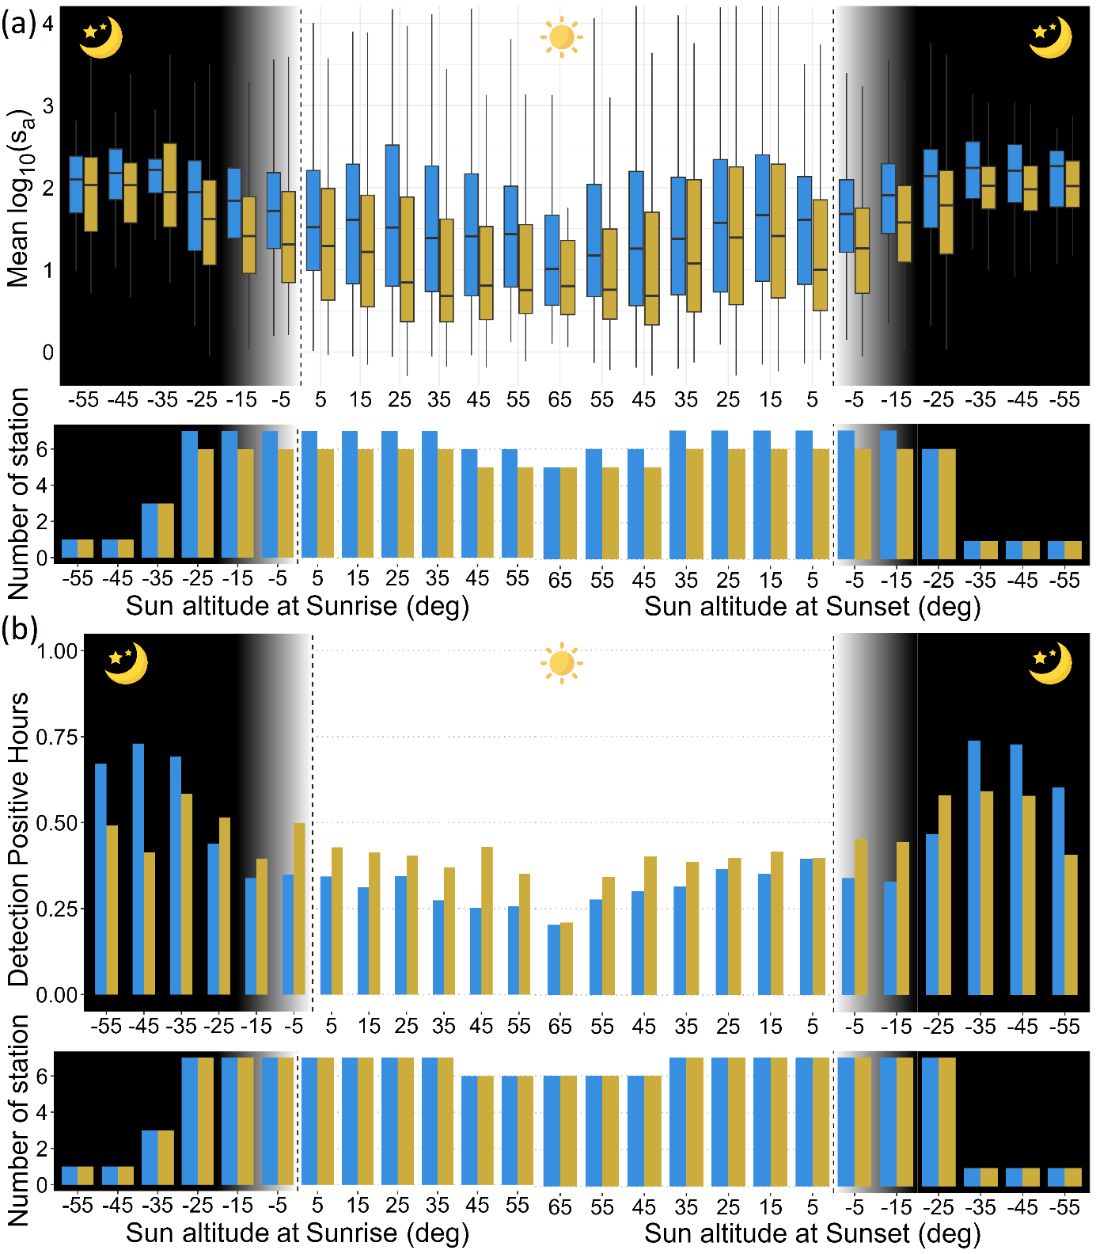

Figure 3: Diurnal patterns are shown based on the sun's altitude around sunrise and sunset, which serves as a proxy for the time of day, for both control (blue), and OWF (yellow). The white background represents daytime, the grey gradient indicates twilight hours, and the black background represents nighttime. (a) The fish area backscattering coefficient is higher at night for both locations. (b) The porpoise detection positive hours are higher at night for both locations. Bars represent the ratio of hours present, and thus no error bars are shown. It is important to note the limited station coverage at the lowest latitudes for both groups, which makes these data points unreplicated.

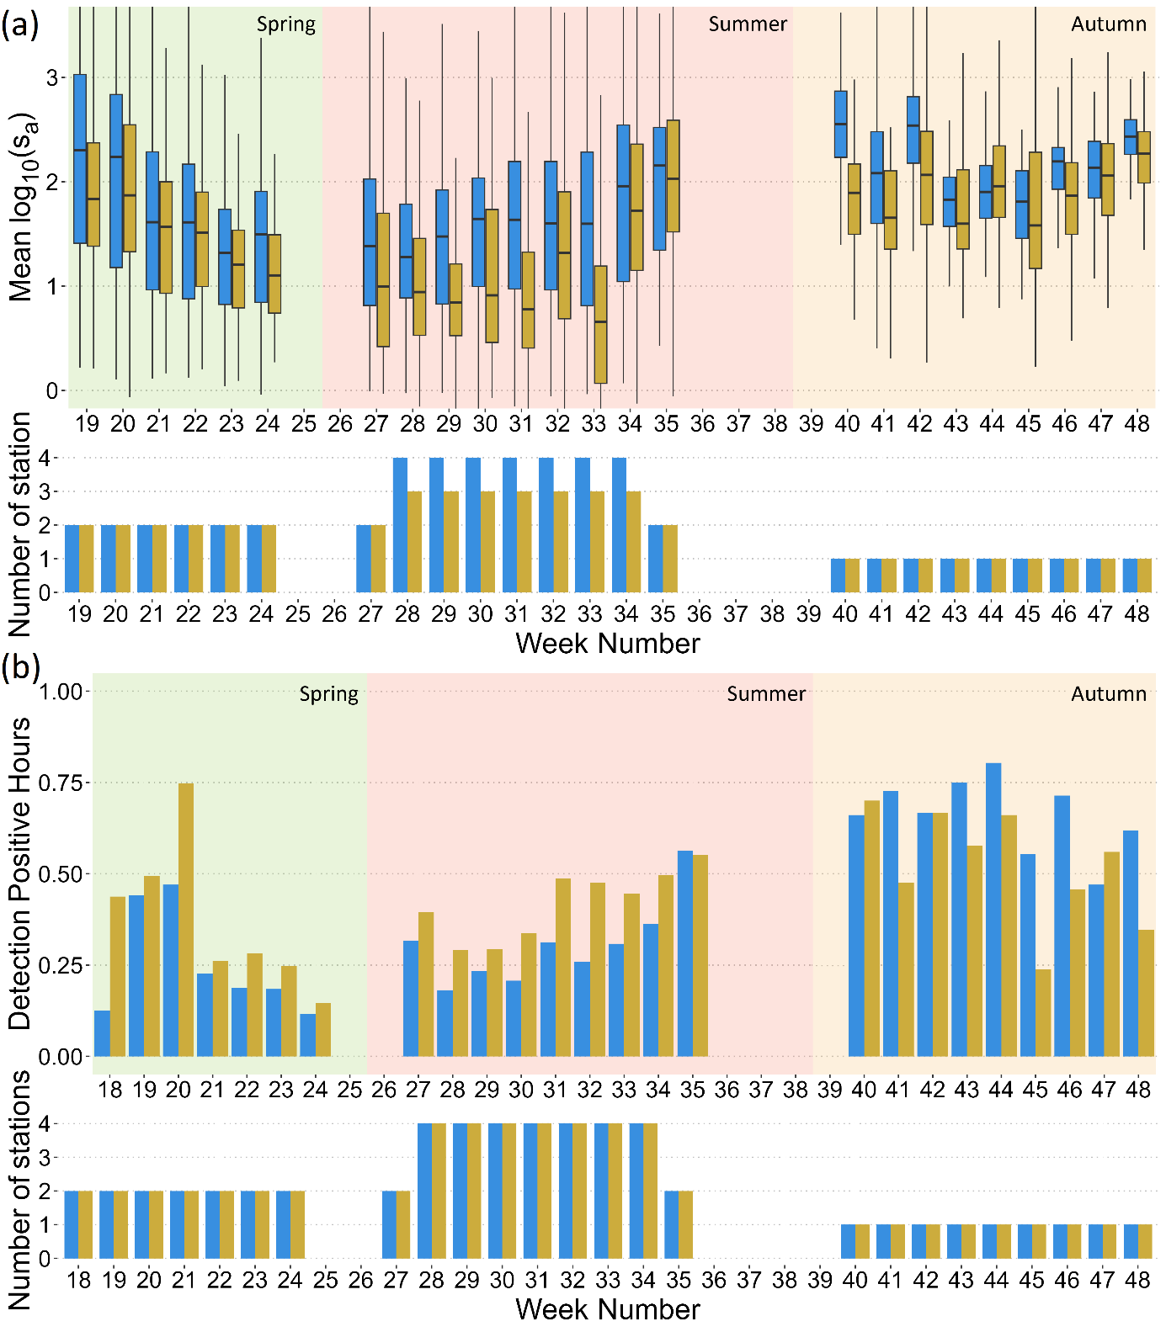

Figure 4: Seasonal patterns are shown based on the week of the year for both control (blue), and OWF (yellow). The background colours do represent studied seasons (spring = green; summer = red; autumn = orange). (a) The fish area backscattering coefficient does decline in spring, increases in summer and is stable in autumn. (b) The porpoise detection positive hours do show a similar pattern. Bars represent the ratio of hours present, and thus no error bars are shown. It is important to note the limited station coverage in autumn, which makes these data points unreplicated.

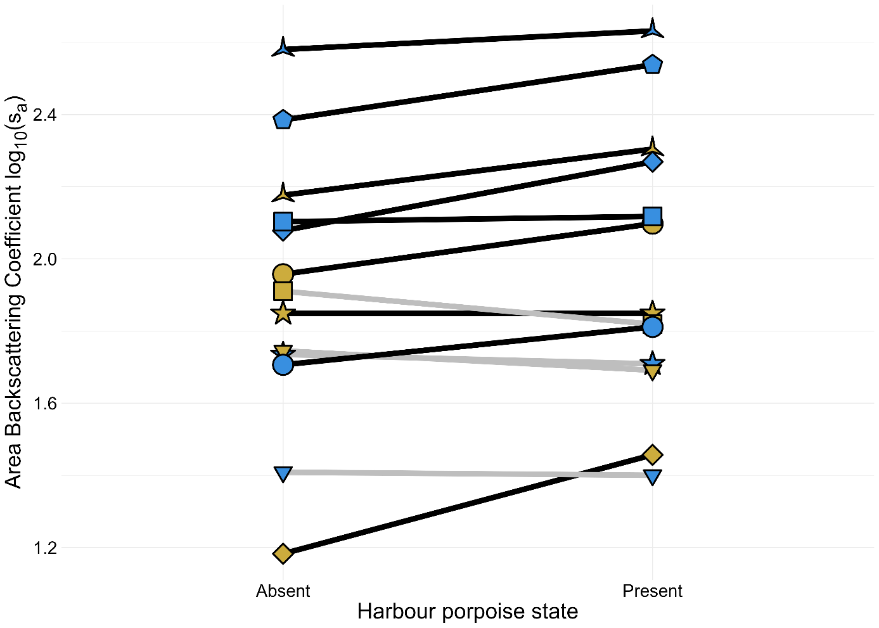

Figure 5: Fish abundance is shown for each individual deployment, against the presence or absence of harbour porpoises. Each line represents a single deployment, and the line colour reflects the porpoise state which has the highest fish abundance (grey = higher biomass when absent; black = higher biomass when present). The point shape represents the deployment pair, and the point colour indicates the location type (control = blue; OWF = yellow). For 10 out of 13 deployments, pelagic fish abundance was significantly higher when harbour porpoises were present.

# Discussion

In the current study, we assessed pelagic fish abundance and harbour porpoise presence using paired deployments of multi-sensor frames in operational OWFs and at control sites near shipwrecks. Our results reveal a lower pelagic fish abundance and a higher harbour porpoise presence in OWFs than at control sites. Both pelagic fish and harbour porpoises expressed seasonal patterns and were increasingly abundant and present at night. Lastly, fish abundance was significantly higher when harbour porpoises were present, revealing a potential predator-prey relationship.

## Pelagic fish inside OWFs

The pelagic fish abundance was significantly lower in OWFs than at control sites. Previous studies have found no difference in pelagic fish abundance between in and outside OWFs, also based on hydroacoustic echosounder measurements (Floeter et al., 2017; Kok et al., 2021). This may be due to methodological differences, as Floeter et al. (2017) used hull-mounted transducers measuring along transects through OWFs rather than making bottom-moored deployments. Kok et al. (2021) provided proof of concept for studying pelagic fish using bottom-moored echosounders but made single-pair deployments, lacking replications to draw firm conclusions on the effect of OWFs. The current study made several replicated paired deployments in multiple OWFs and was, therefore, able to reveal the impact of OWFs.

Several factors may explain lower pelagic fish abundance in OWFs. One possibility is turbine-induced vertical mixing of nutrient-poor and rich water layers reducing local plankton concentrations, though this effect is highly site-dependent, as mixing can also enhance primary production (van der Molen et al. 2014; Floeter et al. 2017; Wang et al. 2024). Since pelagic fish abundance is primarily driven by plankton concentrations in the North Sea, this can impact fish distribution and productivity (Cury et al. 2000). Besides, the scour protection does provide shelter and therefore a shift in species composition toward demersal fish is observed near turbines (Reubens et al., 2014; Stenberg et al. 2015). This might result in fewer pelagic fish species being present, leading to lower fish abundance, as demersal fish live near the seabed or burrow into it, making them undetectable by the echosounder. Furthermore, continuous noise pollution in operational OWFs from rotating turbines and maintenance vessels (Pangerc et al. 2016) could mask communication and or hinder migratory cues disrupting pelagic fish behaviour (Mooney et al., 2020). Fish are known to alter their behaviour in response to elevated ambient noise, exhibiting changes such as different water column usage, horizontal avoidance, and delayed anti-predator responses (Hawkins, Roberts, and Cheesman 2014; Simpson et al. 2016; Cox et al. 2018; Slabbekoorn et al. 2018). As a result, the habitat of the surrounding environment may be more suitable than inside the OWF area. As OWFs did deter pelagic fish, research is needed on how vertical mixing affects plankton concentrations in the southern North Sea, besides eDNA sampling in OWFs to assess fish communities, and lab experiments on the impact of operational OWF-related sounds.

## Harbour porpoise inside OWFs

Harbour porpoise presence was significantly higher in OWFs than at control sites. Previous studies show contradicting results with porpoises being deterred (Teilmann and Carstensen 2012), not being affected (Diederichs et al. 2008; van Polanen Petel et al. 2012; Dähne et al. 2014; Vallejo et al. 2017; Collier et al. 2022), to OWFs attracting harbour porpoises (Lindeboom et al. 2011; Scheidat et al. 2011; Raoux et al. 2017; Fernandez-Betelu et al. 2022). The geographical location of the OWFs is likely a determining factor, as porpoise attraction to OWFs was only found in Scottish waters (Beatrice Bravo) and the southern North Sea (OWEZ)(Scheidat et al. 2011; Fernandez-Betelu et al. 2022). In contrast, studies in the Baltic Sea (Nysted) showed no changes or a deterring effect (Diederichs et al. 2008; Teilmann and Carstensen 2012), and also no impacts were found in the Irish Sea (Robin Rigg) and northern North Sea (Horns Rev & Alpha Venus)(Diederichs et al. 2008; Dähne et al. 2014; Vallejo et al. 2017). This distribution of effects aligns with the general north-south shift in porpoise distribution (Scheidat et al. 2011). However, there are also some contrasting results in the southern North Sea, where aerial surveys showed no changes, though authors noted flight height restrictions near turbines as a limitation (Collier et al. 2022). Studies using C-PODs in the southern North Sea, like the current study, found no changes or attraction to OWFs, where turbine density was suggested as a determining factor, though the exact reasons for these differences remain unclear (Lindeboom et al. 2011; van Polanen Petel et al. 2012; Scheidat et al. 2011). Therefore, the current study made replicated paired deployments allowing us to examine the impacts of operational OWFs with more confidence.

Besides the impact of geographical location, turbines are highly productive areas that support abundant fish and crustacean biomass because of an artificial reef effect (Pickering and Whitmarsh 1997; Love et al. 2019; Degraer et al. 2020). The increased foraging opportunity could explain the higher porpoise presence in OWFs (Fernandez-Betelu et al. 2022), and harbour seals have already been shown to directly navigate between turbines and use them as feeding hotspots (Russell et al. 2014). OWFs may also provide shelter from fishing and vessel traffic, as porpoises are sensitive to high vessel densities (Scheidat et al. 2011; Pigeault et al. 2024). Therefore, the relative disturbance level may be key: in quiet areas, OWFs may have relatively higher human activity than quieter surrounding areas making OWFs disruptive, while in the heavily trafficked southern North Sea, OWFs could offer a relatively calmer refuge. This might explain why OWFs in calmer areas are not attractive for porpoises, as the surrounding habitats might provide superior foraging and living conditions. Overall, we suggest that the reef and shelter effects within OWFs outweigh the adverse impacts of noise pollution and increased human activity in the southern Nord Sea. Further research should focus on filling geographical gaps to distinguish OWF location from seasonal patterns and human activity impacts (Virgili et al. 2024), besides standardising research methods to enhance comparability between studies (Todd et al. 2023).

## Diurnal and seasonal patterns

Both pelagic fish and harbour porpoises revealed strong temporal patterns, with increased nocturnal activity and seasonal variations. Previous studies have already observed nocturnal increases in fish activity (Blaxter and Parrish 1965; Soldal et al. 2002) and porpoises counts (Nuuttila et al. 2018; Clausen et al. 2021; Fernandez-Betelu et al. 2022) around artificial marine structures. This pattern may be explained by the earlier described increase of demersal and semi-pelagic fish species, which are sheltering around hard structures during the day and dispersing into the water column at night (Soldal et al. 2002). As a result, OWFs may become nightly foraging hotspots, driving the increased nocturnal harbour porpoise activity (Clausen et al. 2021; Fernandez-Betelu et al. 2022).

For the seasonal variation, pelagic fish and harbour porpoises revealed lower abundance and presence in spring and summer, with higher levels in autumn. Previous studies in the southern North Sea report similar seasonal effects on fish abundance (Lindeboom et al. 2011) and porpoise presence (Scheidat et al. 2011; Collier et al. 2022). Along the Dutch coast, the pelagic fish community was also found to be highly dynamic across seasons and between years (Grift et al. 2004; Ybema et al. 2009). The seasonal variation in water temperature might explain this pattern, as rising temperatures in spring and summer drive pelagic fish migrations northward, influencing harbour porpoise presence (Lindeboom et al. 2011). Further research should make long-term deployments spanning all seasons and multiple years to further explore how diurnal and seasonal dynamics are affecting pelagic fish and harbour porpoises.

## Pelagic fish – harbour porpoise interaction

We revealed an interaction between fish abundance and harbour porpoise presence, with significantly higher fish abundance when porpoises were present. Previous research already found a link between herring densities and porpoise presence, suggesting pelagic fish are a key component of the porpoise diet (Sveegaard et al. 2012). However, a dietary shift has been observed in the Nord Sea, with porpoises changing from primarily feeding on clupeids like herring (*Clupea harengus*) and sprat (*Sprattus sprattus*) to targeting sand eels (*Ammodytidae*) and cod (*Trisopterus*) (Santos and Pierce 2003; Nuuttila et al. 2018). The declining herring stocks since the 1960s, besides increasing demersal fish abundances in OWFs might have altered porpoise feeding preferences (Santos and Pierce 2003). Further research on the impact of OWF should study fish communities to reveal whether harbour porpoises are targeting different prey species in OWFs.

## Conclusion

The current study examined the impacts of operational OWFs on pelagic fish abundance and harbour porpoise presence using replicated paired bottom-moored deployments. We found fewer pelagic fishes and more harbour porpoises in OWFs than at control sites close to shipwrecks. Both pelagic fish and harbour porpoises revealed strong temporal patterns, with increased nocturnal activity and seasonal variations, with significantly more fish when porpoises were present. Our findings revealed that this OWF zone in the Southern Nord Sea, consisting of multiple OWFs, deterred pelagic fishes while attracting harbour porpoises. Thanks to the paired experimental design, we could isolate and reveal the impact of OWFs, contributing to a broader understanding of their long-term effects on pelagic fish and harbour porpoise behaviour, and providing valuable insights into their suitability as habitats.

# References

Ashley, M. C., S. C. Mangi, and L. D. Rodwell. 2014. ‘The Potential of Offshore Windfarms to Act as Marine Protected Areas – A Systematic Review of Current Evidence’. *Marine Policy* 45 (March):301–9. https://doi.org/10.1016/j.marpol.2013.09.002.

Berges, B.P.J., S.C.V. Geelhoed, M. Scheidat, and J. Tougaard. 2019. ‘Quantifying Harbour Porpoise Foraging Behaviour in CPOD Data: Identification, Automatic Detection and Potential Application’. IJmuiden: Wageningen Marine Research. https://doi.org/10.18174/475270.

Betke, Klaus, Manfred Schultz-von Glahn, and Rainer Matuschek. 2005. ‘Underwater Noise Emissions from Offshore Wind Turbines’, January.

Blaxter, J. H. S., and B. B. Parrish. 1965. ‘The Importance of Light in Shoaling, Avoidance of Nets and Vertical Migration by Herring’. *ICES Journal of Marine Science* 30 (1): 40–57. https://doi.org/10.1093/icesjms/30.1.40.

Brandt, Miriam, AC Dragon, Ansgar Diederichs, MA Bellmann, V Wahl, W Piper, Jacob Nabe-Nielsen, and Georg Nehls. 2018. ‘Disturbance of Harbour Porpoises during Construction of the First Seven Offshore Wind Farms in Germany’. *Marine Ecology Progress Series* 596 (May). https://doi.org/10.3354/meps12560.

Brockmann, U. H., R. W. P. M. Laane, and J. Postma. 1990. ‘Cycling of Nutrient Elements in the North Sea’. *Netherlands Journal of Sea Research* 26 (2): 239–64. https://doi.org/10.1016/0077-7579(90)90092-U.

Chelonia Ltd. 2012. ‘Cetacean Monitoring’. https://www.chelonia.co.uk/index.html.

Clausen, Karin Tubbert, Jonas Teilmann, Danuta M. Wisniewska, Jeppe Dalgaard Balle, Matthieu Delefosse, and Floris M. Van Beest. 2021. ‘Echolocation Activity of Harbour Porpoises, *Phocoena Phocoena* , Shows Seasonal Artificial Reef Attraction despite Elevated Noise Levels Close to Oil and Gas Platforms’. *Ecological Solutions and Evidence* 2 (1): e12055. https://doi.org/10.1002/2688-8319.12055.

Clausen, Karin Tubbert, Magnus Wahlberg, Kristian Beedholm, Stacy Deruiter, and Peter Teglberg Madsen. 2011. ‘CLICK COMMUNICATION IN HARBOUR PORPOISES *PHOCOENA PHOCOENA*’. *Bioacoustics* 20 (1): 1–28. https://doi.org/10.1080/09524622.2011.9753630.

CMACS. 2003. ‘A Baseline Assessment of Electromagnetic Fields Generated by Offshore Windfarm Cables’.

Collier, M. P., R. P. Middelveld, R. S. A. van Bemmelen, F. Weiß, C. G. Irwin, and R. C. Fijn. 2022. ‘High-Definition Bird and Marine Mammal Aerial Survey Image Collection in Borssele: First-Year Report.’, December.

Cox, Kieran, Lawrence P. Brennan, Travis G. Gerwing, Sarah E. Dudas, and Francis Juanes. 2018. ‘Sound the Alarm: A Meta-Analysis on the Effect of Aquatic Noise on Fish Behavior and Physiology’. *Global Change Biology* 24 (7): 3105–16. https://doi.org/10.1111/gcb.14106.

Cury, Philippe, Andrew Bakun, Robert J. M. Crawford, Astrid Jarre, Renato A. Quiñones, Lynne J. Shannon, and Hans M. Verheye. 2000. ‘Small Pelagics in Upwelling Systems: Patterns of Interaction and Structural Changes in “Wasp-Waist” Ecosystems’. *ICES Journal of Marine Science* 57 (3): 603–18. https://doi.org/10.1006/jmsc.2000.0712.

Daan, N., P. J. Bromley, J. R. G. Hislop, and N. A. Nielsen. 1990. ‘Ecology of North Sea Fish’. *Netherlands Journal of Sea Research* 26 (2): 343–86. https://doi.org/10.1016/0077-7579(90)90096-Y.

Dähne, Michael, Verena Peschko, Anita Gilles, Klaus Lucke, Sven Adler, Katrin Ronnenberg, and Ursula Siebert. 2014. ‘Marine Mammals and Windfarms: Effects of Alpha Ventus on Harbour Porpoises’. In *Ecological Research at the Offshore Windfarm Alpha Ventus: Challenges, Results and Perspectives*, edited by Federal Maritime and Hydrographic Agency and Nature Conservation and Nuclear Safety Federal Ministry for the Environment, 133–49. Wiesbaden: Springer Fachmedien. https://doi.org/10.1007/978-3-658-02462-8_13.

Dannheim, Jennifer, Lena Bergström, Silvana N R Birchenough, Radosław Brzana, Arjen R Boon, Joop W P Coolen, Jean-Claude Dauvin, et al. 2020. ‘Benthic Effects of Offshore Renewables: Identification of Knowledge Gaps and Urgently Needed Research’. Edited by Joanna Norkko. *ICES Journal of Marine Science* 77 (3): 1092–1108. https://doi.org/10.1093/icesjms/fsz018.

Degraer, Steven, Drew Carey, Joop Coolen, Zoe Hutchison, Francis Kerckhof, Bob Rumes, and Jan Vanaverbeke. 2020. ‘Offshore Wind Farm Artificial Reefs Affect Ecosystem Structure and Functioning: A Synthesis’. *Oceanography* 33 (December):48–57. https://doi.org/10.5670/oceanog.2020.405.

Denderen, P. Daniël van, Martin Lindegren, Brian R. MacKenzie, Reg A. Watson, and Ken H. Andersen. 2018. ‘Global Patterns in Marine Predatory Fish’. *Nature Ecology & Evolution* 2 (1): 65–70. https://doi.org/10.1038/s41559-017-0388-z.

Diederichs, Ansgar, Veit Hennig, and Georg Nehls. 2008. ‘Investigations of the Bird Collision Risk and the Responses of Harbour Porpoises in the Offshore Wind Farms Horns Rev, North Sea, and Nysted, Baltic Sea, in Denmark Part II: Harbour Porpoises’.

‘EMODnet’. 2024. https://emodnet.ec.europa.eu/geoviewer/.

Farkat Diógenes, Jamil Ramsi, José Coelho Rodrigues, Maria Caroline Farkat Diógenes, and João Claro. 2020. ‘Overcoming Barriers to Onshore Wind Farm Implementation in Brazil’. *Energy Policy* 138 (March):111165. https://doi.org/10.1016/j.enpol.2019.111165.

Fernandez-Betelu, Oihane, Isla M. Graham, and Paul M. Thompson. 2022. ‘Reef Effect of Offshore Structures on the Occurrence and Foraging Activity of Harbour Porpoises’. *Frontiers in Marine Science* 9 (September):980388. https://doi.org/10.3389/fmars.2022.980388.

Floeter, Jens, Justus E. E. van Beusekom, Dominik Auch, Ulrich Callies, Jeffrey Carpenter, Tim Dudeck, Sabine Eberle, et al. 2017. ‘Pelagic Effects of Offshore Wind Farm Foundations in the Stratified North Sea’. *Progress in Oceanography* 156 (August):154–73. https://doi.org/10.1016/j.pocean.2017.07.003.

Frelat, Romain, Susanne Kortsch, Ingrid Kröncke, Hermann Neumann, Marie C. Nordström, Pierre E. N. Olivier, and Anne F. Sell. 2022. ‘Food Web Structure and Community Composition: A Comparison across Space and Time in the North Sea’. *Ecography* 2022 (2). https://doi.org/10.1111/ecog.05945.

Gilles, A, M Authier, NC Ramirez-Martinez, H Araújo, A Blanchard, J Carlström, C Eira, et al. 2023. ‘Estimates of Cetacean Abundance in European Atlantic Waters in Summer 2022 from the SCANS-IV Aerial and Shipboard Surveys’, September.

Grift, Rob, I. Tulp, M.S. Ybema, and Abraham S. Couperus. 2004. ‘Base Line Studies North Sea Wind Farms: Final Report Pelagic Fish’. https://edepot.wur.nl/148435.

Hawkins, Anthony D., Louise Roberts, and Samuel Cheesman. 2014. ‘Responses of Free-Living Coastal Pelagic Fish to Impulsive Sounds’. *The Journal of the Acoustical Society of America* 135 (5): 3101–16. https://doi.org/10.1121/1.4870697.

Hermans, Annemiek, Hendrik V. Winter, Andrew B. Gill, and Albertinka J. Murk. 2024. ‘Do Electromagnetic Fields from Subsea Power Cables Effect Benthic Elasmobranch Behaviour? A Risk-Based Approach for the Dutch Continental Shelf’. *Environmental Pollution* 346 (April):123570. https://doi.org/10.1016/j.envpol.2024.123570.

Hubert, Jeroen, Jozefien M. Demuynck, M. Rafa Remmelzwaal, Carlota Muñiz, Elisabeth Debusschere, Benoit Berges, and Hans Slabbekoorn. 2024. ‘An Experimental Sound Exposure Study at Sea: No Spatial Deterrence of Free-Ranging Pelagic Fisha)’. *The Journal of the Acoustical Society of America* 155 (2): 1151–61. https://doi.org/10.1121/10.0024720.

Iafrate, Joseph D., Stephanie L. Watwood, Eric A. Reyier, Douglas M. Scheidt, Georges A. Dossot, and Steven E. Crocker. 2016. ‘Effects of Pile Driving on the Residency and Movement of Tagged Reef Fish’. *PLOS ONE* 11 (11): e0163638. https://doi.org/10.1371/journal.pone.0163638.

Inger, Richard, Martin J. Attrill, Stuart Bearhop, Annette C. Broderick, W. James Grecian, David J. Hodgson, Cheryl Mills, et al. 2009. ‘Marine Renewable Energy: Potential Benefits to Biodiversity? An Urgent Call for Research’. *Journal of Applied Ecology* 46 (6): 1145–53. https://doi.org/10.1111/j.1365-2664.2009.01697.x.

Jammar, C., A. Reynés-Cardona, J. Vanaverbeke, N. Lefaible, T. Moens, S. Degraer, and U. Braeckman. 2025. ‘Decadal Trends in Macrobenthic Communities in Offshore Wind Farms: Disentangling Turbine and Climate Effects’. *Journal of Sea Research* 203 (February):102557. https://doi.org/10.1016/j.seares.2024.102557.

Klima, Edward F., and Donald A. Wickham. 1971. ‘Attraction of Coastal Pelagic Fishes with Artificial Structures’. *Transactions of the American Fisheries Society* 100 (1): 86–99. https://doi.org/10.1577/1548-8659(1971)100<86:AOCPFW>2.0.CO;2.

Kok, Annebelle C.M., Lisa Bruil, Benoit Berges, Serdar Sakinan, Elisabeth Debusschere, Jan Reubens, Dick De Haan, Alain Norro, and Hans Slabbekoorn. 2021. ‘An Echosounder View on the Potential Effects of Impulsive Noise Pollution on Pelagic Fish around Windfarms in the North Sea’. *Environmental Pollution* 290 (December):118063. https://doi.org/10.1016/j.envpol.2021.118063.

Kok, Annebelle C.M., J. Pamela Engelberts, Ronald A. Kastelein, Lean Helder-Hoek, Shirley Van De Voorde, Fleur Visser, and Hans Slabbekoorn. 2018. ‘Spatial Avoidance to Experimental Increase of Intermittent and Continuous Sound in Two Captive Harbour Porpoises’. *Environmental Pollution* 233 (February):1024–36. https://doi.org/10.1016/j.envpol.2017.10.001.

Krägefsky, Sören. 2014. ‘Effects of the Alpha Ventus Offshore Test Site on Pelagic Fish’. In *Ecological Research at the Offshore Windfarm Alpha Ventus: Challenges, Results and Perspectives*, edited by Federal Maritime and Hydrographic Agency and Nature Conservation and Nuclear Safety Federal Ministry for the Environment, 83–94. Wiesbaden: Springer Fachmedien. https://doi.org/10.1007/978-3-658-02462-8_10.

Lambert, Elke. 2021. ‘THE FEEDING ECOLOGY OF THE HARBOUR PORPOISE Phocoena Phocoena L. IN A CHANGING ENVIRONMENT’, January.

Lefaible, Nene, Ulrike Braeckman, Steven Degraer, Jan Vanaverbeke, and Tom Moens. 2023. ‘A Wind of Change for Soft-Sediment Infauna within Operational Offshore Windfarms’. *Marine Environmental Research* 188 (June):106009. https://doi.org/10.1016/j.marenvres.2023.106009.

Lemasson, Anaëlle J., Paul J. Somerfield, Michaela Schratzberger, Murray S. A. Thompson, Louise B. Firth, Elena Couce, C. Louise McNeill, et al. 2024. ‘A Global Meta-Analysis of Ecological Effects from Offshore Marine Artificial Structures’. *Nature Sustainability* 7 (4): 485–95. https://doi.org/10.1038/s41893-024-01311-z.

Lindeboom, H J, H J Kouwenhoven, M J N Bergman, S Bouma, S Brasseur, R Daan, R C Fijn, et al. 2011. ‘Short-Term Ecological Effects of an Offshore Wind Farm in the Dutch Coastal Zone; a Compilation’. *Environmental Research Letters* 6 (3): 035101. https://doi.org/10.1088/1748-9326/6/3/035101.

Love, Milton S, Jeremy T Claisse, and Alexa Roeper. 2019. ‘An Analysis of the Fish Assemblages around 23 Oil and Gas Platforms off California with Comparisons with Natural Habitats’. *Bulletin of Marine Science* 95 (4): 477–514. https://doi.org/10.5343/bms.2018.0061.

Maclennan, David N., Paul G. Fernandes, and John Dalen. 2002. ‘A Consistent Approach to Definitions and Symbols in Fisheries Acoustics’. *ICES Journal of Marine Science* 59 (2): 365–69. https://doi.org/10.1006/jmsc.2001.1158.

Madsen, Pt, M Wahlberg, J Tougaard, K Lucke, and P Tyack. 2006. ‘Wind Turbine Underwater Noise and Marine Mammals: Implications of Current Knowledge and Data Needs’. *Marine Ecology Progress Series* 309 (March):279–95. https://doi.org/10.3354/meps309279.

Marmo, Brett, Denise Risch, Nienke Van Geel, and Guy Favill. 2024. ‘Underwater Sound Produced by Operational Floating Wind Turbines’. *INTER-NOISE and NOISE-CON Congress and Conference Proceedings* 270 (6): 5512–23. https://doi.org/10.3397/IN_2024_3607.

Molen, Johan van der, Helen C. M. Smith, Paul Lepper, Sian Limpenny, and Jon Rees. 2014. ‘Predicting the Large-Scale Consequences of Offshore Wind Turbine Array Development on a North Sea Ecosystem’. *Continental Shelf Research* 85 (August):60–72. https://doi.org/10.1016/j.csr.2014.05.018.

Mooney, Aran, Mathias Andersson, and Jenni Stanley. 2020. ‘Acoustic Impacts of Offshore Wind Energy on Fishery Resources: An Evolving Source and Varied Effects Across a Wind Farm’s Lifetime’. *Oceanography* 33 (4): 82–95. https://doi.org/10.5670/oceanog.2020.408.

Nuuttila, Hanna K., Chiara M. Bertelli, Anouska Mendzil, and Nessa Dearle. 2018. ‘Seasonal and Diel Patterns in Cetacean Use and Foraging at a Potential Marine Renewable Energy Site’. *Marine Pollution Bulletin* 129 (2): 633–44. https://doi.org/10.1016/j.marpolbul.2017.10.051.

Palomera, I., M. P. Olivar, J. Salat, A. Sabatés, M. Coll, A. García, and B. Morales-Nin. 2007. ‘Small Pelagic Fish in the NW Mediterranean Sea: An Ecological Review’. *Progress in Oceanography*, Ecological Functioning of the Iberian Seas: A synthesis of GLOBEC Research in Spain and Portugal, 74 (2): 377–96. https://doi.org/10.1016/j.pocean.2007.04.012.

Peltier, Helene, Hans J. Baagøe, Kees C. J. Camphuysen, Richard Czeck, Willy Dabin, Pierre Daniel, Rob Deaville, et al. 2013. ‘The Stranding Anomaly as Population Indicator: The Case of Harbour Porpoise Phocoena Phocoena in North-Western Europe’. Edited by Athanassios C. Tsikliras. *PLoS ONE* 8 (4): e62180. https://doi.org/10.1371/journal.pone.0062180.

Petersen, Jens Kjerulf, and Torleif Malm. 2006. ‘Offshore Windmill Farms: Threats to or Possibilities for the Marine Environment’. *Ambio* 35 (2): 75–80.

Pickering, Helen, and David Whitmarsh. 1997. ‘Artificial Reefs and Fisheries Exploitation: A Review of the “Attraction versus Production” Debate, the Influence of Design and Its Significance for Policy’. *Fisheries Research* 31 (1): 39–59. https://doi.org/10.1016/S0165-7836(97)00019-2.

Pigeault, Rémi, Andreas Ruser, Nadya C. Ramírez-Martínez, Steve C. V. Geelhoed, Jan Haelters, Dominik A. Nachtsheim, Tobias Schaffeld, Signe Sveegaard, Ursula Siebert, and Anita Gilles. 2024. ‘Maritime Traffic Alters Distribution of the Harbour Porpoise in the North Sea’. *Marine Pollution Bulletin* 208 (November):116925. https://doi.org/10.1016/j.marpolbul.2024.116925.

Polanen Petel, Tamara van, Steve Geelhoed, and Erik Meesters. 2012. ‘Harbour Porpoise Occurrence in Relation to the Prinses Amaliawindpark’, no. 177 (May).

Püts, Miriam, Alexander Kempf, Christian Möllmann, and Marc Taylor. 2023. ‘Trade-Offs between Fisheries, Offshore Wind Farms and Marine Protected Areas in the Southern North Sea – Winners, Losers and Effective Spatial Management’. *Marine Policy* 152 (June):105574. https://doi.org/10.1016/j.marpol.2023.105574.

R Core Team. 2023. *R: A Language and Environment for Statistical Computing*. Vienna, Austria: R Foundation for Statistical Computing. https://www.R-project.org/.

Raoux, Aurore, Samuele Tecchio, Jean-Philippe Pezy, Géraldine Lassalle, Steven Degraer, Dan Wilhelmsson, Marie Cachera, et al. 2017. ‘Benthic and Fish Aggregation inside an Offshore Wind Farm: Which Effects on the Trophic Web Functioning?’ *Ecological Indicators* 72 (January):33–46. https://doi.org/10.1016/j.ecolind.2016.07.037.

Reubens, J. T., S. Degraer, and M. Vincx. 2014. ‘The Ecology of Benthopelagic Fishes at Offshore Wind Farms: A Synthesis of 4 Years of Research’. *Hydrobiologia* 727 (1): 121–36. https://doi.org/10.1007/s10750-013-1793-1.

Russell, Deborah J. F., Sophie M. J. M. Brasseur, Dave Thompson, Gordon D. Hastie, Vincent M. Janik, Geert Aarts, Brett T. McClintock, Jason Matthiopoulos, Simon E. W. Moss, and Bernie McConnell. 2014. ‘Marine Mammals Trace Anthropogenic Structures at Sea’. *Current Biology* 24 (14): R638–39. https://doi.org/10.1016/j.cub.2014.06.033.

Sadorsky, Perry. 2021. ‘Wind Energy for Sustainable Development: Driving Factors and Future Outlook’. *Journal of Cleaner Production* 289 (March):125779. https://doi.org/10.1016/j.jclepro.2020.125779.

Santos, M B, and G J Pierce. 2003. ‘The Diet of Harbour Porpoise (Phocoena Phocoena) in the Northeast Atlantic’.

Schaffeld, T, S Bräger, A Gallus, M Dähne, K Krügel, A Herrmann, M Jabbusch, et al. 2016. ‘Diel and Seasonal Patterns in Acoustic Presence and Foraging Behaviour of Free-Ranging Harbour Porpoises’. *Marine Ecology Progress Series* 547 (April):257–72. https://doi.org/10.3354/meps11627.

Scheidat, Meike, Jakob Tougaard, Sophie Brasseur, Jacob Carstensen, Tamara van Polanen Petel, Jonas Teilmann, and Peter Reijnders. 2011. ‘Harbour Porpoises ( Phocoena Phocoena ) and Wind Farms: A Case Study in the Dutch North Sea’. *Environmental Research Letters* 6 (2): 025102. https://doi.org/10.1088/1748-9326/6/2/025102.

Simmonds, John, and David Maclennan. 2008. ‘Acoustic Instruments’. In *Fisheries Acoustics*, 70–126. John Wiley & Sons, Ltd. https://doi.org/10.1002/9780470995303.ch3.

Simpson, Stephen D., Andrew N. Radford, Sophie L. Nedelec, Maud C. O. Ferrari, Douglas P. Chivers, Mark I. McCormick, and Mark G. Meekan. 2016. ‘Anthropogenic Noise Increases Fish Mortality by Predation’. *Nature Communications* 7 (1): 10544. https://doi.org/10.1038/ncomms10544.

Slabbekoorn, Hans, Robert J. Dooling, Arthur N. Popper, and Richard R. Fay, eds. 2018. *Effects of Anthropogenic Noise on Animals*. Vol. 66. Springer Handbook of Auditory Research. New York, NY: Springer New York. https://doi.org/10.1007/978-1-4939-8574-6.

Slavik, Kaela, Carsten Lemmen, Wenyan Zhang, Onur Kerimoglu, Knut Klingbeil, and Kai W. Wirtz. 2019. ‘The Large-Scale Impact of Offshore Wind Farm Structures on Pelagic Primary Productivity in the Southern North Sea’. *Hydrobiologia* 845 (1): 35–53. https://doi.org/10.1007/s10750-018-3653-5.

Soldal, Ingvald Svellingen, Terje Jørgensen, and Svein Løkkeborg. 2002. ‘Rigs-to-Reefs in the North Sea: Hydroacoustic Quantification of Fish in the Vicinity of a “Semi-Cold” Platform’. *ICES Journal of Marine Science* 59 (suppl): S281–87. https://doi.org/10.1006/jmsc.2002.1279.

Sonny, D., F. R. Knudsen, P. S. Enger, T. Kvernstuen, and O. Sand. 2006. ‘Reactions of Cyprinids to Infrasound in a Lake and at the Cooling Water Inlet of a Nuclear Power Plant’. *Journal of Fish Biology* 69 (3): 735–48. https://doi.org/10.1111/j.1095-8649.2006.01146.x.

Stenberg, C, Jg Støttrup, M Van Deurs, Cw Berg, Ge Dinesen, H Mosegaard, Tm Grome, and Sb Leonhard. 2015. ‘Long-Term Effects of an Offshore Wind Farm in the North Sea on Fish Communities’. *Marine Ecology Progress Series* 528 (May):257–65. https://doi.org/10.3354/meps11261.

Stephenson, R.L., and R.K. Smedbol. 2001. ‘Small Pelagic Species Fisheries’. In *Encyclopedia of Ocean Sciences*, 468–73. Elsevier. https://doi.org/10.1016/B978-012374473-9.00447-1.

Sveegaard, S, J Nabe-Nielsen, Kj Stæhr, Tf Jensen, Kn Mouritsen, and J Teilmann. 2012. ‘Spatial Interactions between Marine Predators and Their Prey: Herring Abundance as a Driver for the Distributions of Mackerel and Harbour Porpoise’. *Marine Ecology Progress Series* 468 (November):245–53. https://doi.org/10.3354/meps09959.

Teilmann, Jonas, and Jacob Carstensen. 2012. ‘Negative Long Term Effects on Harbour Porpoises from a Large Scale Offshore Wind Farm in the Baltic—Evidence of Slow Recovery’. *Environmental Research Letters* 7 (4): 045101. https://doi.org/10.1088/1748-9326/7/4/045101.

The European Green Deal. 2019. ‘Communication from the Commission to the European Parliament, the European Council, the Council, the European Economic and Social Committee and the Committee of the regionsThe European Green Deal’. https://eur-lex.europa.eu/resource.html?uri=cellar:b828d165-1c22-11ea-8c1f-01aa75ed71a1.0002.02/DOC_1&format=PDF.

Thieurmel, Benoit, and Achraf Elmarhraoui. 2022. ‘Suncalc: Compute Sun Position, Sunlight Phases, Moon Position and Lunar’. https://CRAN.R-project.org/package=suncalc.

Todd, Nicole Rose Eileen, Ailbhe Sarah Kavanagh, Emer Rogan, and Mark John Jessopp. 2023. ‘What the F-POD? Comparing the F-POD and C-POD for Monitoring of Harbor Porpoise (Phocoena Phocoena)’. *Ecology and Evolution* 13 (6): e10186. https://doi.org/10.1002/ece3.10186.

Tougaard, Jakob, Jacob Carstensen, Jonas Teilmann, Henrik Skov, and Per Rasmussen. 2009. ‘Pile Driving Zone of Responsiveness Extends beyond 20 Km for Harbor Porpoises (Phocoena Phocoena (L.))’. *The Journal of the Acoustical Society of America* 126 (1): 11–14. https://doi.org/10.1121/1.3132523.

Vallejo, Gillian C., Kate Grellier, Emily J. Nelson, Ross M. McGregor, Sarah J. Canning, Fiona M. Caryl, and Nancy McLean. 2017. ‘Responses of Two Marine Top Predators to an Offshore Wind Farm’. *Ecology and Evolution* 7 (21): 8698–8708. https://doi.org/10.1002/ece3.3389.

Van de Pol, Lennert, Katrien Van der Biest, Sue Ellen Taelman, Laura De Luca Peña, Gert Everaert, Simon Hernandez, Fiona Culhane, et al. 2023. ‘Impacts of Human Activities on the Supply of Marine Ecosystem Services: A Conceptual Model for Offshore Wind Farms to Aid Quantitative Assessments’. *Heliyon* 9 (3): e13589. https://doi.org/10.1016/j.heliyon.2023.e13589.

Van Der Knaap, Inge, Jan Reubens, Len Thomas, Michael A. Ainslie, Hendrik V. Winter, Jeroen Hubert, Bruce Martin, and Hans Slabbekoorn. 2021. ‘Effects of a Seismic Survey on Movement of Free-Ranging Atlantic Cod’. *Current Biology* 31 (7): 1555-1562.e4. https://doi.org/10.1016/j.cub.2021.01.050.

Virgili, Auriane, Sophie Laran, Matthieu Authier, Ghislain Dorémus, Olivier Van Canneyt, and Jérôme Spitz. 2024. ‘Prospective Modelling of Operational Offshore Wind Farms on the Distribution of Marine Megafauna in the Southern North Sea’. *Frontiers in Marine Science* 11 (February):1344013. https://doi.org/10.3389/fmars.2024.1344013.

Wang, Lijing, Bangguo Wang, Wenxi Cen, Rui Xu, Yuwei Huang, Xin Zhang, Yinghui Han, and Yuanxun Zhang. 2024. ‘Ecological Impacts of the Expansion of Offshore Wind Farms on Trophic Level Species of Marine Food Chain’. *Journal of Environmental Sciences* 139 (May):226–44. https://doi.org/10.1016/j.jes.2023.05.002.

Watson, Stephen C. L., Paul J. Somerfield, Anaëlle J. Lemasson, Antony M. Knights, Andrew Edwards-Jones, Joana Nunes, Christine Pascoe, et al. 2024. ‘The Global Impact of Offshore Wind Farms on Ecosystem Services’. *Ocean & Coastal Management* 249 (March):107023. https://doi.org/10.1016/j.ocecoaman.2024.107023.

Williams, Terrie M., James A. Estes, Daniel F. Doak, and Alan M. Springer. 2004. ‘KILLER APPETITES: ASSESSING THE ROLE OF PREDATORS IN ECOLOGICAL COMMUNITIES’. *Ecology* 85 (12): 3373–84. https://doi.org/10.1890/03-0696.

Wilson, D.E., and R.A. Mittermeier. 2014. *Handbook of the Mammals of the World*. (Eds). Vol. 4: Sea Mammals. Barcelona: Lynx Edicions.

WindEurope. 2019. ‘Offshore Wind in Europe: Key Trends and Statistics 2019’. https://windeurope.org/wp-content/uploads/files/about-wind/statistics/WindEurope-Annual-Offshore-Statistics-2019.pdf.

Wisniewska, Danuta Maria, Mark Johnson, Jonas Teilmann, Ursula Siebert, Anders Galatius, Rune Dietz, and Peter Teglberg Madsen. 2018. ‘High Rates of Vessel Noise Disrupt Foraging in Wild Harbour Porpoises (Phocoena Phocoena)’. *Proceedings of the Royal Society B: Biological Sciences* 285 (1872): 20172314. https://doi.org/10.1098/rspb.2017.2314.

Wisniewska, Danuta Maria, Mark Johnson, Jonas Teilmann, Laia Rojano-Doñate, Jeanne Shearer, Signe Sveegaard, Lee A. Miller, Ursula Siebert, and Peter Teglberg Madsen. 2016. ‘Ultra-High Foraging Rates of Harbor Porpoises Make Them Vulnerable to Anthropogenic Disturbance’. *Current Biology* 26 (11): 1441–46. https://doi.org/10.1016/j.cub.2016.03.069.

Wood, Simon N. 2011. ‘Fast Stable Restricted Maximum Likelihood and Marginal Likelihood Estimation of Semiparametric Generalized Linear Models’. *Journal of the Royal Statistical Society: Series B (Statistical Methodology)* 73 (1): 3–36. https://doi.org/10.1111/j.1467-9868.2010.00749.x.

Xu, Wenxuan, Yongxue Liu, Wei Wu, Yanzhu Dong, Wanyun Lu, Yongchao Liu, Bingxue Zhao, Huiting Li, and Renfei Yang. 2020. ‘Proliferation of Offshore Wind Farms in the North Sea and Surrounding Waters Revealed by Satellite Image Time Series’. *Renewable and Sustainable Energy Reviews* 133 (November):110167. https://doi.org/10.1016/j.rser.2020.110167.

Ybema, M S, Dominik Gloe, and Reinier Hille Ris Lambers. 2009. ‘OWEZ Pelagic Fish, Progress Report and Progression after T1’. https://edepot.wur.nl/198566.

Zupan, Mirta, Joop Coolen, Ninon Mavraki, Steven Degraer, Tom Moens, Francis Kerckhof, Lucia Lopez Lopez, and Jan Vanaverbeke. 2024. ‘Life on Every Stone: Characterizing Benthic Communities from Scour Protection Layers of Offshore Wind Farms in the Southern North Sea’. *Journal of Sea Research* 201 (October):102522. https://doi.org/10.1016/j.seares.2024.102522.

Zupan, Mirta, Bob Rumes, Jan Vanaverbeke, Steven Degraer, and Francis Kerckhof. 2023. ‘Long-Term Succession on Offshore Wind Farms and the Role of Species Interactions’. *Diversity* 15 (2): 288. https://doi.org/10.3390/d15020288.

# Appendix

## Appendix A

Table A: Meta information on the five OWFs included in this study showing country, number of turbines, power (MW), construction date, coastal distance (km), surface area (km2), turbine density (turbines/km2), yield per turbine (MW), lastly and yield per surface area (MW/km2).

|  |  |  |  |  |  |  |  |  |  |
| --- | --- | --- | --- | --- | --- | --- | --- | --- | --- |
| Name OWF | Country | Meta information on offshore wind farms | | | | | | | |
|  |  | No. of Turbines | Power (MW) | Construct-ion date | Coastal distance (km) | Surface area (km2) | Turbine density (T/km2) | Yield per Turbine (MW) | Yield per km2 (MW) |
| Belwind phase 1 | Belgium | 55 | 165 | 2010 | 40.61 | 14.74 | 3.73 | 3.00 | 11.19 |
| C-Power (Zone A) | Belgium | 24 | 141 | 2013 | 24.79 | 10.68 | 2.25 | 5.88 | 13.20 |
| C-Power (Zone B) | Belgium | 30 | 184 | 2013 | 25.04 | 9.17 | 3.27 | 6.13 | 20.07 |
| Borssele II | Netherlands | 47 | 376 | 2020 | 24.23 | 63.53 | 0.74 | 8.00 | 5.92 |
| Borssele IV | Netherlands | 40 | 380 | 2020 | 40.22 | 74.70 | 0.54 | 9.50 | 5.09 |

## Appendix B

Table B: Meta information on the five shipwrecks included in the study showing the country, size metrics (m), coastal distance (km), bow degree from Nord and sinking date.

|  |  |  |  |  |  |  |  |  |
| --- | --- | --- | --- | --- | --- | --- | --- | --- |
| Name Wreck | Country | Meta information on shipwrecks | | | | | | |
|  |  | Depth (m) | Length (m) | Width (m) | Height (m) | Coastal distance (km) | Bow degrees from Nord | Sinking date |
| Birkenfels | Belgium | 39 | 156.1 | 18.7 | 31.1 | 52 | 169.8 | 1966 |
| Gardencity | Belgium | 32 | 147.6 | 18.5 | 12.4 | 47 | 27 | 1969 |
| Grafton | Belgium | 19.3 | 98.4 | 10.1 | 3.5 | 19 | 63 | 1940 |
| BSW1 | Netherlands | 25.9 | 34 | 9 | 5 | 35 | 216 | NA |
| BSW2 | Netherlands | 19.2 | 67 | 14 | NA | 23 | 131 | NA |

## Appendix C

Figure C: An overview of the deployments across different locations is provided, with the start of the deployment period marked in green and the end in red. The deployment durations ranged from 6 to 10 weeks and occurred in 2021 and 2023.